|  |
| --- |
| BOX WORLD |
| Box World |
| **[First Person Shooter]** |
| Version 1  All work Copyright © 2015 Centennial College.  All rights reserved. |
| **[Abobaker Belal - 300748727]** |
|  |



**Insert a Company Logo here**

|  |
| --- |
| November 20th 2015 |

Table of Contents

Contents

Version History 3

Game Description 4

Controls 4

Interface Sketch 5

Menu and Screen Descriptions 6

Characters/Vehicles 9

Enemies 9

Scoring 9

Sound Index 10

Art / Multimedia Index 10

Sources 12

Version History

**November 10: Version 1**

Simple setup of the game, found sprites and audio to use, and created all folders, and game objects.

**November 13: Version 2**

Touch up on the game objects and added components (scripts)

**November 15: Version 3**

Added player control, and background loop.

**November 17: Version 4**

Touch up on the scripts (colliders, audio, etc.)

**November 20: Version 5**

Added scoring and death visuals to the screen

Game Description

**STORY:**

Box World is a first person shooter game, where the player is playing the role of a hero who does not belong in the world of boxes. The game takes place in a Box dominated world, any other shape is put down and destroyed by the evil boxes. But one shape is fighting against that ideology, and is trying bring all the shapes together. The player is playing the main role which is a sphere.

The sphere tries to rescue all other shapes from the evil boxes (triangle, pentagon, octagon, etc.). Rescuing other shapes gives the sphere points, and rescuing a capsule gives him extra life. The capsule is a cowardly shape and tries to run away from the sphere because the sphere is a rebel. Capturing the capsule gives bonus life.

**Description:**

The game starts off with the main menu giving the option to start the game. Once the start button is selected, the main game scene is launched, where Sphere will have to save as many survivors as he can. Once the player has no more lives left or they have beat the level, another scene will come up where it will show their score.

Controls

The main controls for this game are mouse and keyboard.

KEYBOARD CONTROLS:

W OR up-arrow =Forward  
A OR left-arrow =Move-Left  
S OR down-arrow =Move-Down  
D OR right-arrow =Right-Arrow

Spacebar =Jump

Hold Spacebar =float

Mouse Controls:

Left-Click = Shoot laser

Interface Sketch

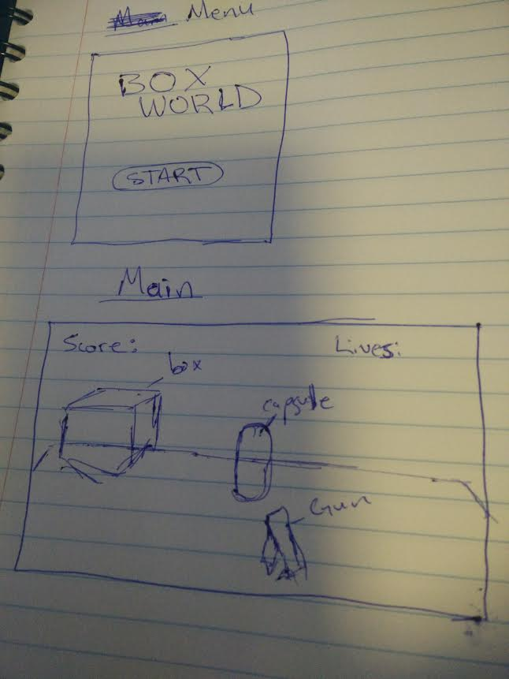

Menu and Screen Descriptions

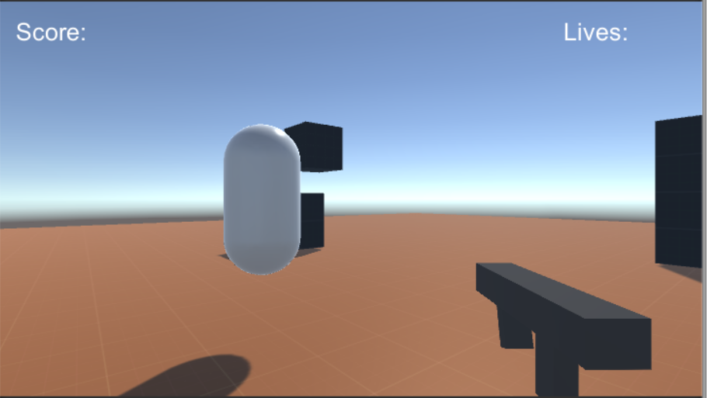

Box

Gun

Capsule

Lives

Score

This will be the in-game interface, the player will be controlling the Sphere located down at the bottom of the screen. Score will be displayed at top left, and lives will be displayed at top right. Main goal of the game is to save as many survivors as you can, while dodging the incoming boxes which can damage the sphere.

Characters/Vehicles

The main character’s avatar is a Sphere. Which can shoot laser’s at incoming boxes. The boxes are slow moving but high in numbers. Different shapes offer different amount of points, except capsule shapes which provides life.

Enemies

The enemies in the game will be dropping from the top of the screen at random X and Z locations. They in groups of 5. The enemies also drift either left or right, some even upwards but at slower speed. Their speed dropping varies anywhere from 3 to 6 units.

Scoring

Score in this game is calculated by how many shapes the player can save. Each shape counts as one point. Player starts the game with 5 lives, and they must save as many shapes as they can with 5 lives. This does not change anytime in the game.

Sound Index

There are no sound index in this game.